**User Manual**

This is our user manual. This will explain everything our program is capable of doing. User will start of at the welcome screen when first opening the program.

# Welcome screen.

* Login Button: Takes the user to the login screen.



# Login Screen

* Username: Ask user to input their username given to them by the Admin
* Password: ask the user to input they created or given to them by the Admin

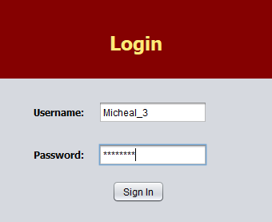

* Sign in Button:
  + Signs the user in if all their credentials are correct.
    - Determines if the user is a student or an Admin before taking them to the home screen.
  + Or displays error message if something is incorrect. Lets the user try again.

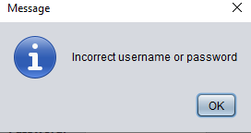

# Student Home Screen

* Will display their current class schedule (if they have one), ID Number, GPA, & number of credits they have (if any).

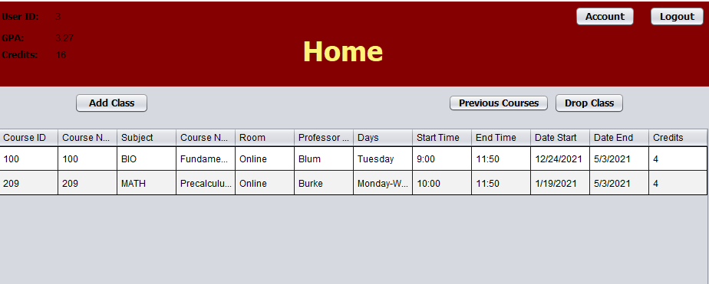

* Previous Courses Button: This button will display all the courses the student has taken (if they have any).
* Account Button: Let’s student edit their phone number, email and update their password.
* Add class button: Will take the student to the search screen. So, they can look at classes to add.
* Logout button: Will log the student out and bring them back to the login screen.
* Drop Class button: This button will drop any class that is selected.
  + If no class is selected the error message “Select a class first” will appear

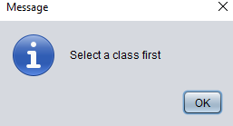

# Previous Course

* Displays all courses taken by the student.
* Return button: Takes the student back to the home page.
* Logout button: Will log the student out and bring them back to the login screen.

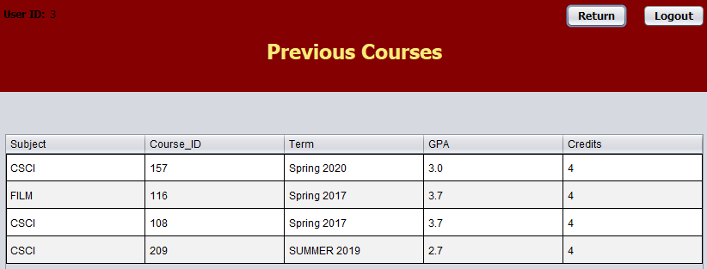

# Student Account Screen

* Student can update their phone number and email.
  + Then click the update button. This will update the database.

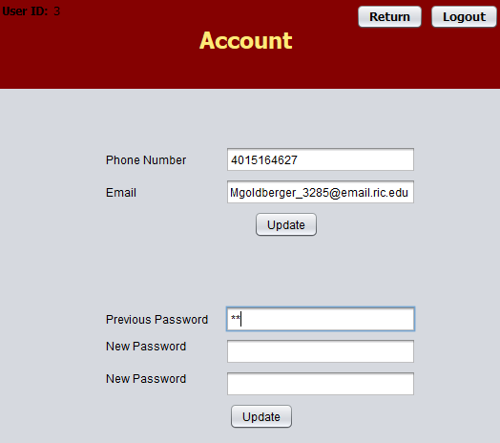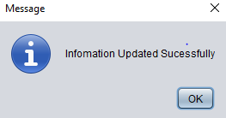

* Students can update their password.
  + Will ask student to enter old password first.
  + Then will ask student to enter new password twice.
  + Then click the update button. This will update the database.
  + If they enter the wrong password, they will get an error message

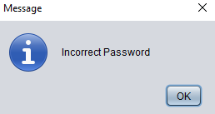

# Class Search Screen

* Search Button: Will allow students to search for a class they want.
  + If they leave the text field blank. It will bring all of the classes available to take.

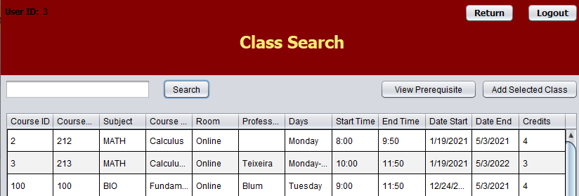

* + If they enter the name or part of a name. It will bring up all the classes that contain that name in the title.

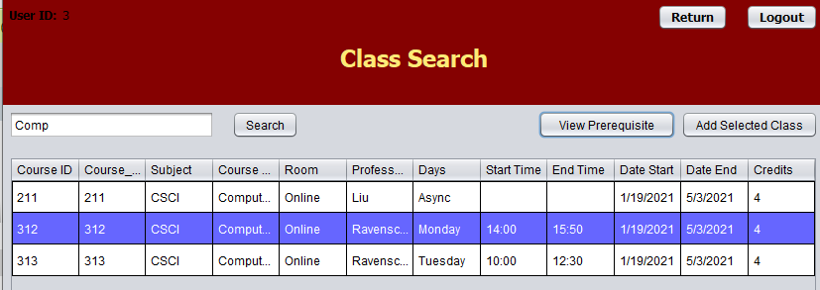

* + If they enter the course ID number. It will only bring up the specific course.

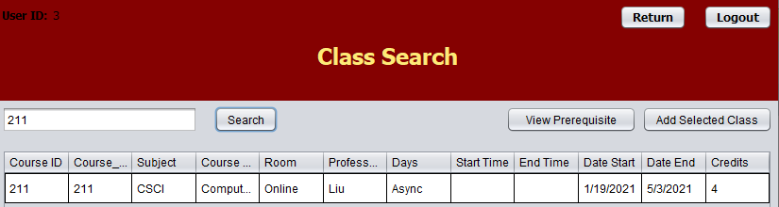

* View Prerequisite button: Will show all of the prerequisites for a class a student has selected.

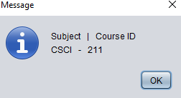

* Add Selected class button: Will add the selected class to the student’s schedule granted the students meets these 2 requirements.
  + The first one is that the student has taken the prerequisites if the course has any.

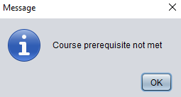

* + The second one is that the student does not have any other class that meets at the same time.

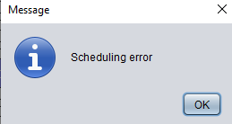

* + Both of these will provide error messages if not met.
* Logout button: Will log the student out and bring them back to the login screen.
* Return button: Will bring the student back to the home screen.

# Admin Home Screen

* Will allow the Admin to do a variety of actions that will impact the application and database.

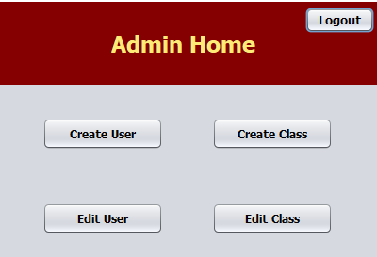

* Create User button: will take the admin to the create user screen where they can create an account for a professor or student.
* Create Class button: Will take admin to the create class screen where they can create a new class.
* Edit User button: Will take admin to edit user screen. Where they can edit existing users.
* Edit Class button: Will take admin to edit class screen. Where they can edit existing classes.
* Logout button: Will log the admin out and bring them back to the login screen.

# Create User Screen

* Will allow the admin to create 2 types of users student or professor.
* Home button: Will take the Admin to the home page.
* Logout button: Will log the admin out and bring them back to the login screen.
* Drop down menu: Allows to pick between 2 user types.
  + Professor: Asks a variety of info
    - ID number (ID) – Integer
    - First Name (Fname) - String
    - Last Name (Lname) - String
    - Email - String
    - Phone – Integer

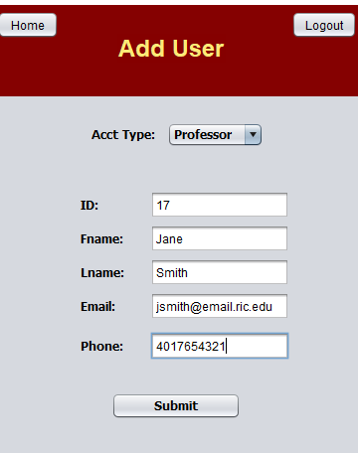

* + Student: Asks a variety of info
    - ID Number (ID) - Integer
    - First Name (Fname) – String
    - Last Name (Lname) - String
    - Username - String
    - Password – String/hash
    - Email - String
    - Phone - Integer
    - Credits - Integer
    - GPA- Float

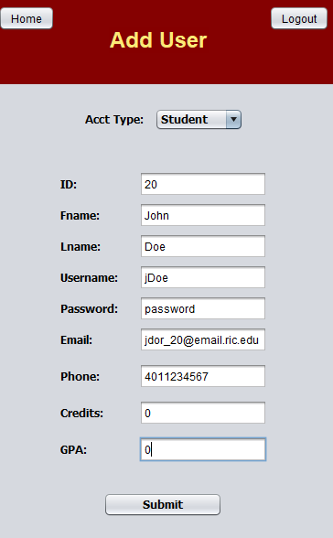

* Submit button: will submit user info to the database.

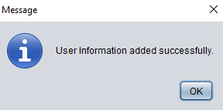

# Create Class Screen

* Will ask info about the class that is being created.
  + Course ID
  + Course Number
  + Subject
  + Course Name
  + Room
  + Professor Name
  + Days
  + Time start (Military time)
  + Time End (Military Time)
  + Date Start (MM/DD/YYYY)
  + Date End (MM/DD/YYYY)
  + Credits
  + Pre-Req (prerequisite if the class has one)

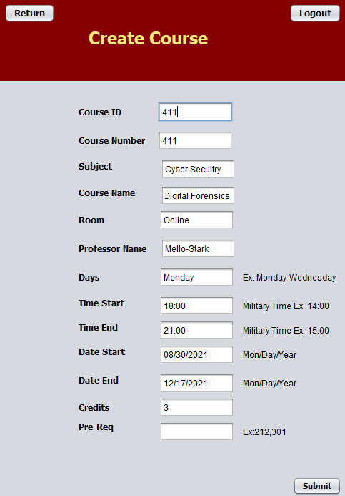

* Return button: Will take the admin to the home page.
* Logout button: Will log the admin out and bring them back to the home screen.
* Submit button: will submit course info to the database.

# Edit User Screen

* Will allow admin to edit any user.

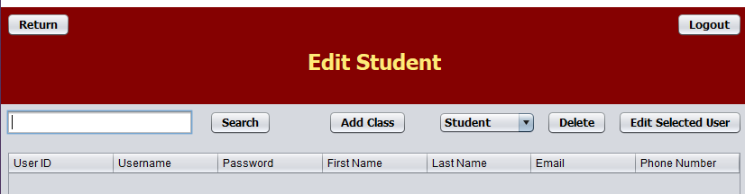

* Drop-down menu will allow admin to pick between student and professor to edit.
* Admin can search by ID number or by name.

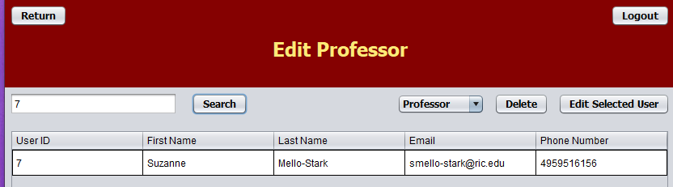

* Delete button: Will delete selected user and will confirm Admin wants to delete selected user.

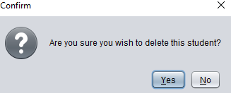

* Edit Selected User button: Will allow to save any changed that the admin has made to the highlighted user.

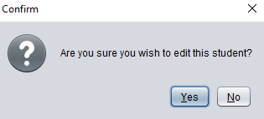

* For students there is an Add class button that will allow the admin to add a class to a student’s schedule that they are not able to add themselves.
* Return button: Will bring the admin back to the home screen.
* Logout button: Will log the admin out and bring them back to the login screen.

# Edit Class

* Admin can search by class ID or by name.
* Edit Selected Class button: Will allow admin to make any changes to the selected class. They first have to select the field they want to edit by double clicking and then make the edits they want.

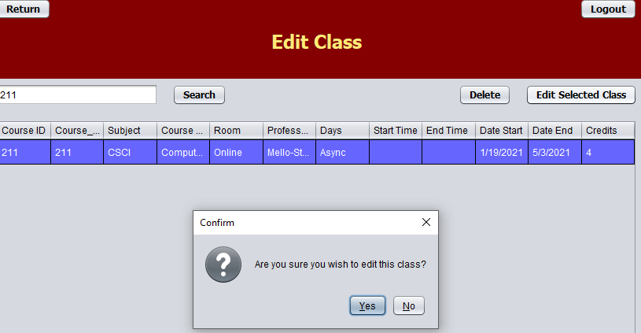

* Delete button: Will allow the admin to delete selected class.

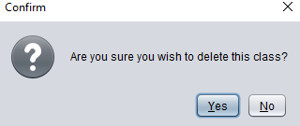

* Return button: Will bring the admin back to the home screen.
* Logout button: Will log the student out and bring them back to the login screen.